  FOUNDATIONs ON RAISING CAPITAL  Professional Practise 3 (PFP360S) | Name: Thabiso Matsaba  Student Number: 220296006  Email: 220296006@mycput.ac.za  Lecturer: Bhadra Ranchod  Due Date: 30 April 2022

District 6 Cloud Solutions
We are the Cloud in your Sky.
What’s the Problem?
- At District 6 Cloud Solutions we help our clients to transition from native systems to Cloud based services and solutions using Infrastructure-as-a-Service (IaaS).
Cost
- Cloud infrastructure offers major cost savings on operating expenses. Cloud customers get all the components and services they need delivered through the cloud, rather than creating, building, managing, and maintaining a data centre. This saves huge amounts of spending on electricity bills, IT expertise, hardware, servers, and software that accompany a physical data centre. Instead, cloud infrastructure enables businesses to pay for only the data storage and computing power they need as and when they require it.
Agility and flexibility
- Cloud infrastructures are highly agile and flexible because they are self-managed and allow service changes to be made in a matter of minutes. This increases uptime and makes business systems efficient, enabling users to access shared data through mobile or Internet-of-Things (IoT) devices as necessary. As a result, organizations become more focused on business and issues that drive the bottom line than being bogged down in IT matters.
Security
- The cloud is often looked down on with scepticism for being insecure or making data easy to compromise. But enterprise-level cloud infrastructures are highly secure environments primed to protect organizations’ data against cyberattacks, viruses, and data breaches through advanced firewalls and encryption keys. Furthermore, a hybrid cloud approach enables organizations to securely store their most sensitive data in private clouds while providing great user experiences by storing fewer sensitive applications and big data in public clouds.

What Is Your Solution?
- To grow our company, we need to look at how to attract investment capital for our business. This can be achieved through angel and venture capital investors.
- Angel Investors are high net worth individuals who invest their own money into companies. This type of capital investor is what we need to start competing in the market.
- Venture investment capital is the other solution we can take since we are creating a high-growth, scalable tech company, venture capital is the rocket fuel that we need.
- Due to the COVID-19 pandemic, the rise in remote work and IT services has risen significantly in last 2 years with more people choosing to stay remote than go back to work. We believe this is the best time start our business as the ICT industry market is doubling every year.

Competitive Marketplace Analysis?
- South Africa has one of the largest information and communications technology (ICT) markets in Africa.
- As an increasingly important contributor to South Africa’s GDP, the country’s ICT and electronics sector is both sophisticated and developing. Several international corporates operate subsidiaries from South Africa, including IBM, Unisys, Microsoft, Intel, Systems Application Protocol (SAP), Dell, Novell, and Compaq. It is seen as a regional hub and a supply base for neighbouring countries.
- Business software spending may be driven by customer-centric industries such as retail, financial and telecoms, where businesses are recognizing that solutions can be a competitive differentiator. Cloud-based software products are expected to drive growth.
- We at District 6 Cloud Solutions can leverage and use the opportunities within organizations looking for assistance in utilizing efficiencies from cloud computing such as Infrastructure-as-a-Service(IaaS).
- Cloud computing is becoming more important due to improved bandwidth availability, security, and lowered cost of broadband, as well as additional internet providers competing in the market.
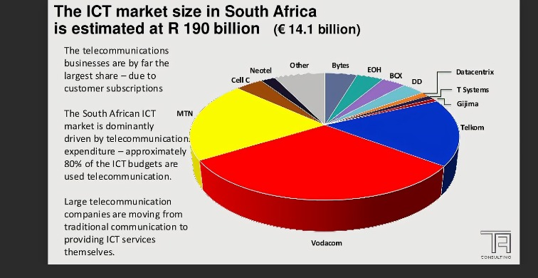
Who Are You, and Why Are You on the Team?
- I as the CEO of the company Thabiso Matsaba have a good team of young, talented, and hungry IT developers.
- 1 ICT Communication Network Developer.
- 1 ICT Multimedia Developer.
- 2 ICT Software Developers.
What Is Your Ask?
- For District 6 Cloud Solutions to have a chance in the market we need the following:
- Cloud Serves
- Laptops and Computers
- Bandwidth
- Office Space to Rent
- Monthly Salaries
All of this will need an initial R1 000 000 investment to get the business running.

